Advanced Java:
J2EE is meant for developing web applications.
We need 3 types of APIs:
- JDBC API (To Establish connection from Java Application + Database)
- Servlet API(To write Business Logic for Web Application by using Servlet class)
- JSP API(To write Business Logic for Web Application by using JSP File)
---------------------------------------------------------------------------------------------------------------
MVC Architecture:
M – Model – The model is implemented by JDBC API
V -View – The View Layer is implemented BY JSP API (JSP for Designing Purpose + Prepare Business Logic)
C - Controller – Controller Layer is implemented by using Servlet API
------------------------------------------------------------------------------------------------------------------
Java Framework:
- Hibernate to implement the model layer like JDBC
- Spring to develop web applications with concise code
- Spring boot to develop web applications + Rest API + Micro Services.
---------------------------------------------------------------------------------------------------------------
Hibernate Framework: Implemented for Model layer only
Spring + Spring Boot Framework: Implemented with three layers (MVC)

------------------------------------------------------------------------------------------------
Working with framework <-> working with war and jar files
JAR – java Archieve files – used to develop standalone applications
WAR – Web Archieve files – used to develop web applications + Dynamic web applications
EAR – Enterprise Archieve files – used to develop Dynamic Web Applications (e-commerce applications)
-------------------------------------------------------------------------------------------------------
Every Java Project / Application Required Softwares:
- JDK – java software
- IDE (Integrated Development Environment) – Ecllipse – Editing the java code
- Tomcat Server (servlet class, JSP files)
- Browser (run static files(.html,.css,.js))
- Database software (MySQL, Oracle DB)

- Why framework?
  - Every real time project contains atleast some functionalities.
  - If developers are defining the code for implementing common functionalities for each project separately then causes issue.
    - It makes a burden on developer
    - It makes delay to deliver a project to the client
    - Project deployment cost is increased and takes more time
To overcome, framework is introduced:
  - Developer can deliver project with in the time
  - A project maintenance is easy
  - Rapid development
  - More secure code
  - Simpler testing and debugging
  - Avoiding duplicate code
  - Able to focus on writing code specific to the project

- What is framework?
  - A framework is a set of jar and war files.
  - Each jar and war contains a set of predefined interfaces, classes and methods to provide some functionality of a java project
  - In other way, framework is an abstraction layer on top of existing technology.
- Types of Framework:
  - Invasive framework
    - It will force the programmers to create their classes by extending or implementing from pre-defined classes or interfaces provided by the framework.
    - Examples: Servlets and Struts
Public class MyServlet implements Servlet (Servlet API)
{
Service(SR request, SR response)
{
//PL (input statements)
//BL (processing statements)
//DAL (jdbc )
//PL (output statements)

}
}
Public class MyServlet extends HttpServlet (servlet API)
{
doPost(HSR request, HSR response)
{
//PL (input statements)
//BL (processing statements)
//DAL (jdbc )
//PL (output statements)
}
}

  - Non-Invasive framework: it wont forces the programmer to extend or implement its own classes or interfaces
Examples: Hibernate, Spring and Spring Boot
These frameworks are designed with POJO and POJI models.

- Advantages of framework?
- Java framework names?
Based on functionality of a java web application / Java project is divided into three layers
- UI (Presentation layer) - .jsp file (Designing purpose)
- Business logic layer – servlet API .java file
- Data Access layer – for storage purpose(JDBC API)

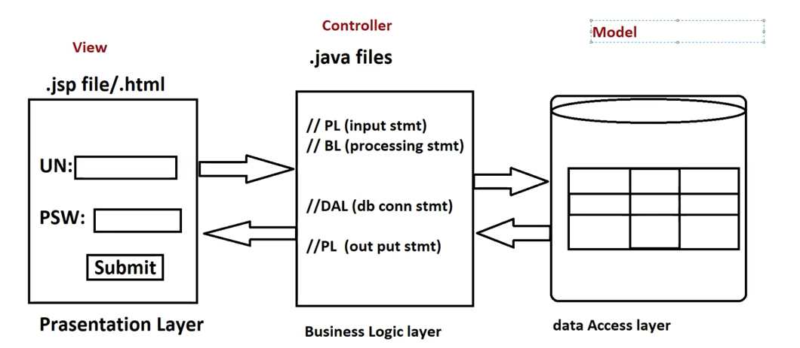

Steps to create Spring Boot Application:
Two ways:
- By using Spring Initializer
  - Visit http://start.spring.io/ web site
  - Select your project artifacts
  - Add required starters/dependencies (jar files)
  - Download ready made maven/gradle project in .zip file
  - Extract the zip file
  - Import that project into ecllpise / IntelliJ IDE
  - Do maven clean & run your application

- By using STS tool
  - Spring Tool Suite is an IDE to develop Spring Applications.
  - It is an Eclipse-based development environment
  - It provides a ready-to-use environment to implement, run, deploy and debug the application.
Steps:
  - Open the String Tool Suite
  - Click on the File Menu -> new -> Spring Starter project
  - Provide the Group ID and Artifact ID and package name then click on finish button

